

***Moldova: Policy advice, legislative drafting and on-going support to the MTender Pilot in 2020.***

***MTENDER DOCUMENT WORKFLOW MANAGEMENT***

***September 2020***

**APPROVAL PAGE**

September 2020

This document for Workflow Management of the project “Moldova: Policy advice, legislative drafting and on-going support to the MTender Pilot in 2020” was first prepared as a draft and submitted on the 15th September 2020 by the Consultant: everis and uStudio. It has gone through a number of iterations, and this version 1.0 is the final version. The document has been examined by the EBRD OL and the representatives of the Government Client/Beneficiaries of Republic of Moldova and is hereby recommended for approval and acceptance.

|  |  |
| --- | --- |
| **Client/beneficiary Name** | **Ministry of Finance of the Republic of Moldova** |
| **Project title** | **Moldova: Policy advice, legislative drafting and on-going support to the MTender Pilot in 2020** |
| **Date of scheduled delivery** | 15/09/2020 |
| **Date of submission for acceptance** | 15/09/2020 |

|  |  |  |
| --- | --- | --- |
| **The output is specified in the table below and includes a list of delivered deliverables. The output is in accordance with approved specifications and complies with all conditions defined in the Contract, as per the Terms of Reference.** | | |
| **Deliverable** | **Deliverable Description** | **Acceptance Date** |
| *P2-T1-A3* | *Document for Workflow Manager* |  |
| **All deliverables were prepared in required quality and time and are accepted without open points.**  **Other comments [….]** | | |

|  |  |  |
| --- | --- | --- |
| **Consultancy & Report Author** | Signature: | Date: |
| **Everis Spain, SLU** |
| **Persons authorised to Sign-off** | Signature: | Date: |
| **Eliza Niewiadomska, EBRD OL** |

*Please be advised that the report has been prepared exclusively for EBRD. EBRD makes no representation or warranty, express or implied, as to the accuracy or completeness of the information set forth in this report. EBRD has not independently verified any of the information contained in the report and EBRD accepts no liability whatsoever for any of the information contained in the report or for any misstatement or omission therein. The report remains EBRD’s property.*

**DOCUMENT CHARACTERISTICS**

|  |  |
| --- | --- |
| **Property** | **Value Proposition** |
| Release date | 15.09.2020 |
| Status: | For review |
| Version: | 1.0 |
| Authors: | uStudio, everis |
| Reviewed by: | EBRD |
| Approved by: |  |

**DOCUMENT HISTORY**

|  |  |  |
| --- | --- | --- |
| **Version** | **Description** | **Date** |
| 1.0 | Document for Workflow Management | *15.09.2020* |
| 2.0 |  |  |
| 3.0 |  |  |
| 4.0 |  |  |
| 5.0 |  |  |

Table of Contents

1. Introduction 6

1.1 Aim of the document 6

1.2 Background 6

2. Proposed solution 7

2.1 Workflow prescription 7

2.2 Workflow fulfilment 9

2.3 Workflow execution 9

3. Annex I. Showcase: conclusion of the contract 12

3.1 Landscape 12

3.2 Incomes 12

3.3 Outcomes 12

4. Annex II. OCDS Extension 13

**LIST OF FIGURES**

Figure 1. BPMN for the Document Workflow Manager 11

Figure 2. Contract signing lifecycle 13

**ABBREVIATIONS**

|  |  |
| --- | --- |
| **Term** | **Description** |
| CA | Contracting Authority |
| CAN | Contract Award Notice |
| CDU | Central Database Unit |
| CN | Contract Notice |
| DB | Database |
| DWM | Document Workflow Manager |
| EBRD | European Bank for Reconstruction and Development |
| EO | Economic Operator |
| NEPPs | Networking Electronic Procurement Platforms |
| OCDPS | Open Contracting Digital Procurement System |
| OCDS | Open Contracting Data Standard |

**GLOSSARY:**

|  |  |
| --- | --- |
| **Term** | **Description** |
| MTender | MTender is an end-to-end eProcurement system implemented in Moldova that aims at covering the full public procurement cycle. It is based on a multi‑platform networking digital procurement model, comprising a government‑operated web portal and the Open Data central database unit, which is networking with several commercial electronic platforms certified to support electronic tendering procedures for public sector and commercial clients. |
| eProcurement | Electronic procurement |

# Introduction

## Aim of the document

The European Bank for Reconstruction and Development (EBRD or the Bank) UNCITRAL Initiative is aimed at digital transformation of public procurement through the implementation of a new eProcurement model branded as Open Contracting Digital Procurement System (OCDPS).

The main purpose of this document is to present the approach for the Document Workflow Manager (DWM), which is a tool within the OCDPS which will allow the management of the workflows aimed at the confirmation or approval of documents.

## Background

Most administrative processes contain steps and tasks that require some sort of confirmation in order to move forward to the next step or action of the process.

For example, the following situations are identified within the public procurement process where confirmation is required to the parties involved in the process:

1. Direct obligations (initiated by the process)
   1. Any significant changes to the tender documents or Contract Notice (CN) itself (to be confirmed by the Contracting Authority (CA))
   2. Cancellation request initiated after publication of CN (to be confirmed by the CA)
   3. Qualification/evaluation decision or protocol to be confirmed by the Contracting Authority (CA)
   4. Bid withdraw initiated after submission of bid (to be confirmed by the Economic Operator (EO))
   5. Contract Award Notice issued according to the outcomes of the tendering procedure (to be confirmed by the CA)
   6. Contract Award Notice (CAN) cancellation request initiated by either the CA or the Review Body (to be confirmed by the CA)
2. Requested obligations (initiated by Parties)
   1. Any parts of the future contracts’ conditions requested by the CA to be confirmed by the EO within submission of bid
   2. Any clarification (either data or document) requested by the CA to be confirmed by the EO during evaluation of his offer
   3. Awarded contract to be confirmed by all involved parties according to their role
   4. Any contract annex requested by the CA to be signed by the EO during contract preparation phase
   5. Any purchase orders issued according to the CA request (to be confirmed by the CA)
   6. Any invoices issued according to EO request (to be confirmed by the EO and signed off by the CA)
   7. Termination request against concluded contract initiated by the CA (to be confirmed by the CA)

In order to provide coverage to the aforementioned situations, a specific digital tool responsible for storing, execution and validation of workflows is needed.

Under this vision, all the requests described above are considered as documents, and the required action-cases are workflows. Consequently, the tool described in this document is a Document Workflow Manager, which will facilitate the management of the workflows aimed at the confirmation or approval of documents.

# Proposed solution

## Workflow prescription

As stated above, each request, either initiated by the system itself or by one of the parties involved in the process, is, in fact, a document.

It is possible to describe document workflows through a system structure which includes:

* The information in a separate (Open Contracting Data Standard) OCDS data-set related to a particular document
* The prescribed requested actions.

For example, as a simplest case, see below the case of a digital contract issued by the system to be signed by parties’ authorities:

|  |
| --- |
| {  "contracts": [  {  "id": "", *// the document attached to be signed by Parties’ authorities*  "documents": [  {  "id": "001",  "documentType": "contractSigned",  "url": ""  }  ],  "confirmationRequests": [ *// set of requests associated with the document*  {  "id": "buyer-001", *// buyers’ obligations*  "type": "digitalSignature", *// type of request fulfillment*   "description": "Contract to be signed by CA",  "relatesTo": "document",  "relatedItem": "001",  "source": "buyer",  "requestGroups": [ *// set of buyers’ authorities whose confirmation required*  {  "id": "buyer-001-buyer.identifier.id",  "requests": [  {  "id": "buyer-001-buyer.identifier.id-relatedPerson.id",  "title": "parties[role:buyer].persones[role:authority].name"  }  ]  }  ]  },  {  "id": "tenderer-001", *// buyers’ obligations*  "type": "digitalSignature", *// type of request fulfillment*   "title": "Contract to be signed by EO"  "relatesTo": "document",  "relatedItem": "001",  "source": "tenderer",  "requestGroups": [ *// set of suppliers’ authorities whose confirmation required*  {  "id": "tenderer-001-tenderer.identifier.id",  "requests": [  {  "id": "tenderer-001-tenderer.identifier.id-relatedPerson.id",  "title": "parties[role:supplier].persones[role:authority].name"  }  ]  }  ]  }  ]  }  ] } |

In the same way, as shown in the example below, any other body involved in the process can be requested to participate in the approval of a specific document:

|  |
| --- |
| {  "contracts": [  {  "id": "",  "documents": [  {  "id": "001",  "documentType": "contractSigned"  "url": ""  }  ],  "confirmationRequests": [  {  "id": "approveBody-001", *// Treasury obligations*  "type": "outsideAction", *// type of request fulfillment*  "description": "Contract to be verified by Treasury",  "relatesTo": "document",  "relatedItem": "001",  "source": "approveBody",  "requestGroups": [ *// set of Treasury authorities whose confirmation required*  {  "id": "approveBody-001-approveBody.identifier.id",  "requests": [  {  "id": "approveBody-001-approveBody.identifier.id",  "title": "parties[role:approveBody].name"  }  ]  }  ]  }  ]  }  ] } |

## Workflow fulfilment

Once a request is published, related responses are expected, and the process will not go ahead until all requested confirmations are received. Such responses can be described as a separate OCDS data-set related to a particular *requirementRequest:*

|  |
| --- |
| {  "confirmationResponses": [  {  "id": "",  "value": {  "name": "",  "id": "",  "date": "",  "relatedPerson": {  "id": "",  "name": ""  },  "verification": [  {  "type": "",  "value": ""  }  ]  },  "request": ""  }  ] } |

As a result of the proposed approach, all the information describing both a prescribed workflow for a particular document and all expected responses satisfying such workflow, can be published as machine-readable OCDS data-sets.

The same approach applies for all data-entities mentioned above:

* amendments / terminations;
* submissions / bids;
* qualification / evaluation decisions and protocols;
* contract award notices / contracts;
* documents;
* requirements / requirement responses.

## Workflow execution

The most important part of this vision is the approach to the management and execution of document workflows. The diagram below reflects the proposed solution:

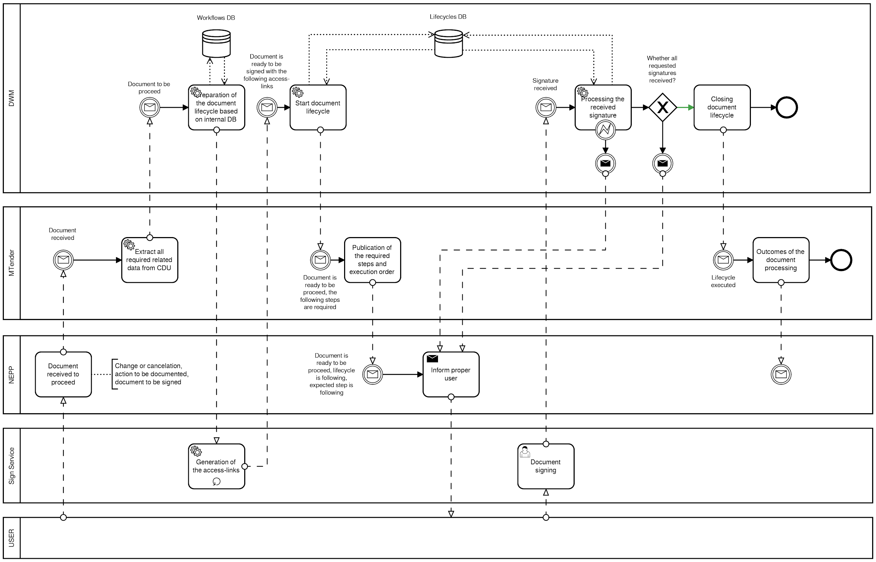

Figure 1. BPMN for the Document Workflow Manager[1]

As described in the scheme above, the DWM should consist of several parts:

* *General logic core:* component responsible for the process execution and validation according to the prescribed (requested) workflow.
* *Workflow DB:* database which contains the available workflows.
* *Lifecycles DB:* database of the documents’ lifecycles for particular workflows that have already been launched.
* *Document Registration Agent:* component responsible for transfer the document from the DWM to the external digital sign service.
* *Event Listener:* component responsible for receiving an initial proceeding on responses from an external digital sign service.

# Annex I. Showcase: conclusion of the contract

This annex provides an example on how the DWM could operate in the conclusion of a contract, retrieving all the information that the contract needs in order to be concluded and all the necessary steps that the system has to run in order to complete the process.

## Landscape

The eProcurement system generates digital contracts based on transactional data (starting from a set of initial conditions of the contract, including selected tenderers’ requirement responses and final agreed metrics).

## Incomes

Central Database Unit (CDU) extracts all the data related to the parties involved in the contract to be signed (legal information, companies profiles, authorities and other authorized personnel, etc.) and sends this information together with meta-attributes (such as country of jurisdiction, legal basis, procurement category, etc.) to the DWM.

## Outcomes

DWM extracts the applicable workflow for the received request and builds the expected life cycle:

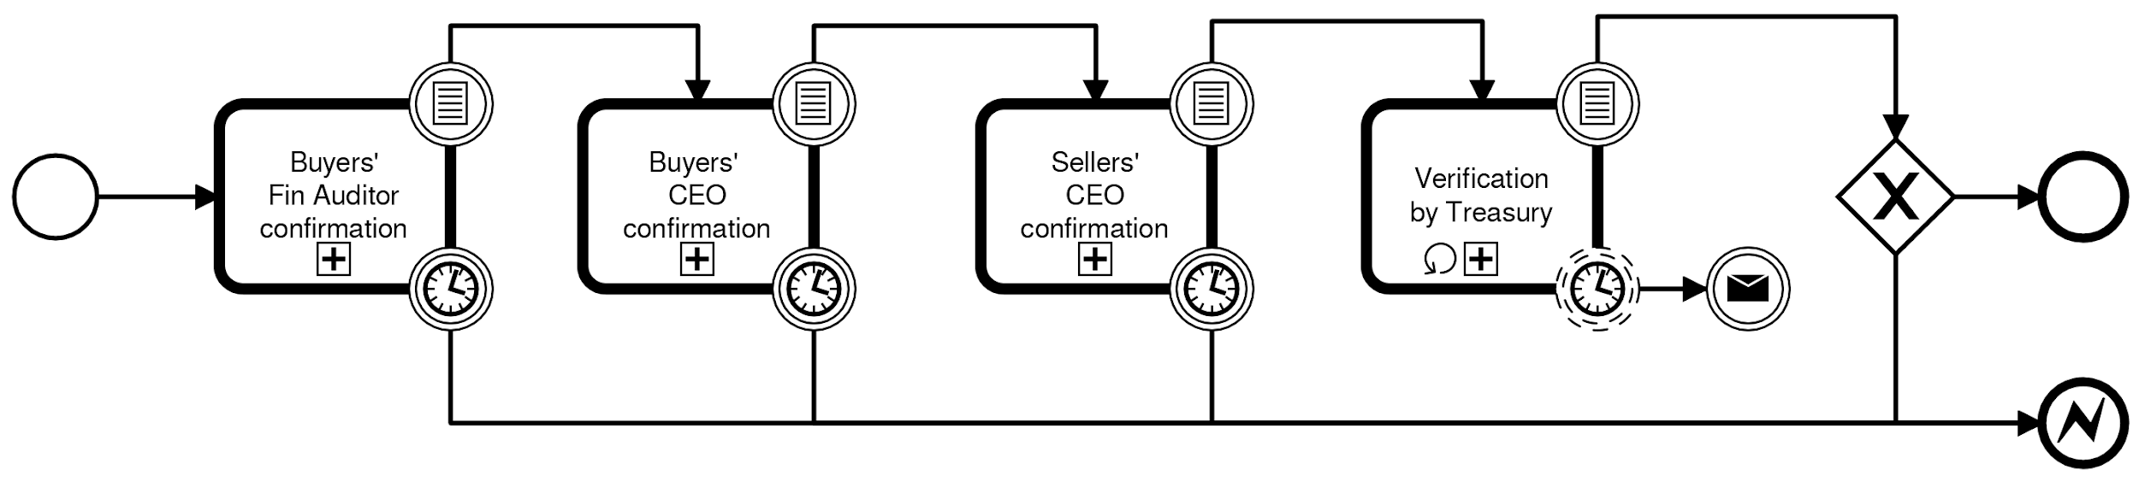

Figure 2. Contract signing lifecycle[2]

According to this lifecycle, the DWM expects to get:

1. Confirmations of responsible of the Buyer (e.g. the CA chairman first and CEO second), received as digital signatures, confirmed by external digital sign service.
2. Confirmation of responsible of the Seller (e.g. just CEO), received as a digital signature, confirmed by external digital sign service.
3. Confirmation of positive verification from State Treasury (e.g. regular representative), received as a data-income through a secured transport channel.

Any difference from the prescribed process (e.g. DWM receives proper confirmation but in a wrong sequence) will be translated to the hosted Networking Electronic Procurement Platforms (NEPP) as an exception, and the DWM will continue to wait for the execution of the expected step.

# Annex II. OCDS Extension

This annex provides information regarding the main OCDS objects used in the Document Workflow Management:

* *ConfirmationRequest*: Separate request for confirmation of the specific action taken or the data-outcome suggested automatically addresses to particular involved party representatives.
* *RequestGroup*: A list of requirements which must all be satisfied for the requirement group to be met.
* *ConfirmationResponse*: An assertion that responds to a single requirement. A requirement response provides the value for the requirement and may provide the period to which it applies.
* *RequirementReference*: Used to cross-reference a requirement.
* *Tender*: Information about how a tender will take place, or has taken place.
* *Award*: Information on awards made as part of a contracting process.
* *Contract*: Information on contracts signed as part of a contracting process.

See below the attributes of the aforementioned objects:

|  |
| --- |
| {  "definitions": {  "ConfirmationRequest": {  "type": "object",  "title": "Confirmation request",  "description": "Separate request for confirmation of the specific action taken or the data-outcome suggested automatically addresses to particular involved party representatives",  "properties": {  "id": {  "title": "Identifier",  "description": "The identifier for this criterion. It must be unique and cannot change within the Open Contracting Process it is part of (defined by a single ocid). See the [identifier guidance](http://standard.open-contracting.org/latest/en/schema/identifiers/) for further details.",  "type": [  "string",  "integer"  ]  },  "type": "string",  "title": {  "title": "Title",  "description": "A title for this criterion.",  "type": "string"  },  "description": {  "title": "Description",  "description": "A description of this criterion. Structured information should be provided in its other fields.",  "type": "string"  },  "source": {  "title": "Source",  "description": "Source of response to the requirements specified in the criterion, for example responses may be submitted by tenderers or by an assessment committee at the procuringEntity.",  "type": "string",  "enum": [  "tenderer",  "buyer",  "procuringEntity",  "approvalBody"  ]  },  "relatesTo": {  "title": "Related schema element",  "description": "The schema element that the criterion judges, evaluates or assesses. For example criterion may be defined against items or against bidders.",  "type": "string",  "enum": [  "document",  "amendment",  "award",  "bid",  "value",  "metric"  ]  },  "relatedItem": {  "title": "Related item",  "description": "Where relatesTo = \"item\" this field must be populated with the id of the item in this tender section which the criterion relates to. Where relatesTo <> \"item\" this field should be omitted.",  "type": "string"  },  "requestGroups": {  "title": "",  "description": "",  "type": "array",  "items": {  "$ref": "#/definitions/RequestGroup"  },  "uniqueItems": true  }  }  },  "RequestGroup": {  "type": "object",  "title": "",  "description": "",  "properties": {  "id": {  "title": "Identifier",  "description": "The identifier for this requirement group. It must be unique and cannot change within the Open Contracting Process it is part of (defined by a single ocid). See the [identifier guidance](http://standard.open-contracting.org/latest/en/schema/identifiers/) for further details.",  "type": "string"  },  "requests": {  "title": "Requests",  "description": "A list requirements which must all be satisfied for the requirement group to be met.",  "type": "array",  "items": {  "$ref": "#/definitions/Requests"  }  }  }  },  "Request": {  "type": "object",  "title": "",  "description": "An atomic requirement. Requirements can specify the expected value that the response has to contain, or a range of threshold values within which the response has to fit in. The requirement may apply to a certain period of time.",  "properties": {  "id": {  "title": "Request identifier",  "description": "The identifier for this requirement. It must be unique and cannot change within the Open Contracting Process it is part of (defined by a single ocid). See the [identifier guidance](http://standard.open-contracting.org/latest/en/schema/identifiers/) for further details.",  "type": "string"  },  "title": {  "title": "Request title",  "description": "The title of this atomic requirement.",  "type": "string"  },  "description": {  "title": "Request description",  "description": "A free text description for this atomic requirement.",  "type": "string"  },  "dataType": {  "title": "Requirement datatype",  "description": "The data type in which the requirement response must be provided.",  "type": "object"  }  }  },  "ConfirmationResponse": {  "type": "object",  "title": "Response",  "description": "An assertion that responds to a single requirement. A requirement response provides the value for the requirement and may provide the period to which it applies.",  "required": [  "id",  "requirement"  ],  "properties": {  "id": {  "title": "Identifier",  "description": "The identifier for this requirement response. It must be unique and cannot change within the Open Contracting Process it is part of (defined by a single ocid). See the [identifier guidance](http://standard.open-contracting.org/latest/en/schema/identifiers/) for further details.",  "type": "string"  },  "title": {  "title": "Title",  "description": "A title for this requirement response.",  "type": "string"  },  "description": {  "title": "Description",  "description": "A description of this requirement response. Structured information should be provided in its other fields.",  "type": "string"  },  "value": {  "title": "Value",  "description": "The value of this requirement response. The value must be of the type defined in the requirement.dataType field.",  "type": [  "string",  "integer",  "number",  "null"  ]  },  "period": {  "title": "Period",  "description": "The period which the requirement response is applicable to.",  "$ref": "#/definitions/Period"  },  "requirement": {  "title": "Related requirement",  "description": "The id and title of the requirement which the response is applicable to.",  "$ref": "#/definitions/RequirementReference"  },  "relatedTenderer": {  "title": "Related tenderer",  "description": "Where this requirement response relates to a tenderer and is provided by the buyer or procuring entity this field should be used to reference the entry in the parties section for the tenderer the response relates to.",  "$ref": "#/definitions/OrganizationReference"  }  }  },  "RequirementReference": {  "type": "object",  "title": "Requirement reference",  "description": "Used to cross reference a requirement.",  "required": [  "id"  ],  "properties": {  "id": {  "title": "Requirement ID",  "description": "The id of the requirement which the response is applicable to.",  "type": "string"  },  "title": {  "title": "Requirement title",  "description": "The title of the requirement which the response is applicable to.",  "type": "string"  }  }  },  "Tender": {  "properties": {  "confirmationRequests": {  "title": "",  "description": "",  "type": "array",  "items": {  "$ref": "#/definitions/ConfirmationRequest"  }  }  }  },  "Award": {  "properties": {  "confirmationRequests": {  "title": "",  "description": "",  "type": "array",  "items": {  "$ref": "#/definitions/ConfirmationRequest"  }  }  }  },  "Contract": {  "properties": {  "requirementResponses": {  "title": "Requirement responses",  "description": "A list of the detailed responses of this contract to the requirements of the tender.",  "type": "array",  "items": {  "$ref": "#/definitions/RequirementResponse"  },  "uniqueItems": true  }  }  }  } } |

1. [*http://bit.ly/2MbQLye*](http://bit.ly/2MbQLye)
2. [*http://bit.ly/2EAIrlp*](http://bit.ly/2EAIrlp)